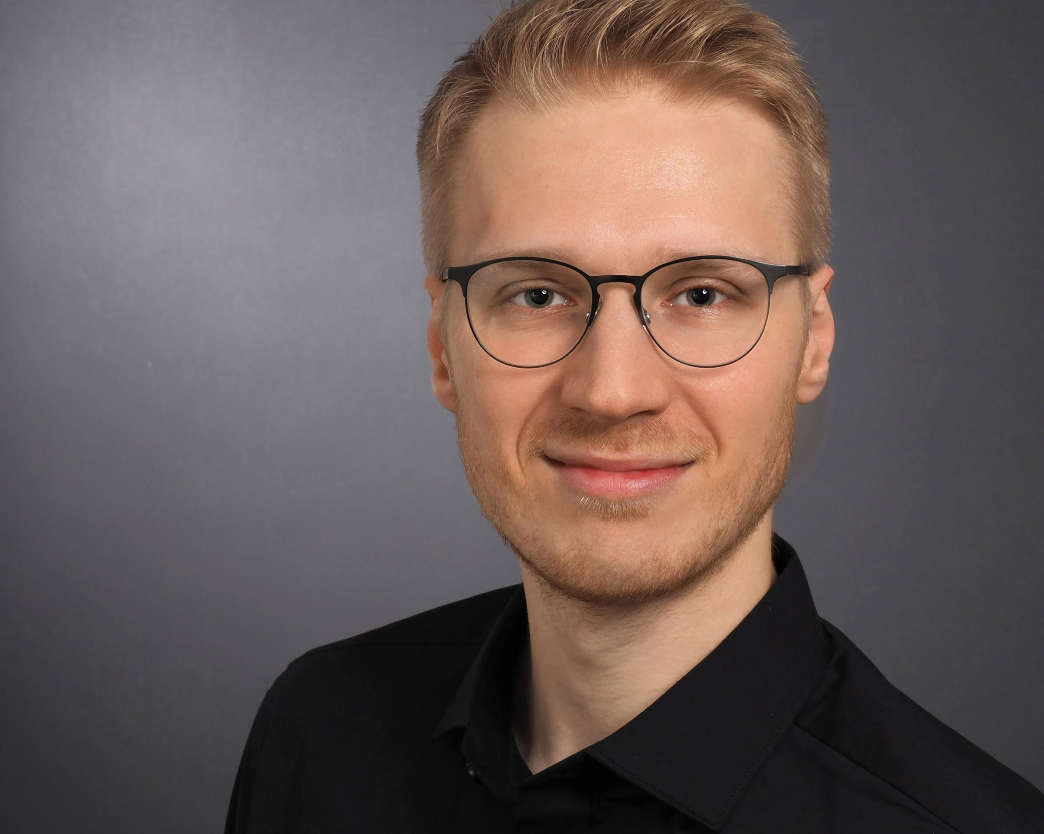**Kai Held**

Cloud/DevOps Engineer

📞 +49 151 41650257

📧 [held@ka1.io](mailto:held@ka1.io)

🌐 <https://ka1.io>

**Skills & Expertise**

**AWS & Cloud** ⬤⬤⬤⬤⬤

* Core-Services: EC2, ECS, EKS, Lambda, API Gateway, DynamoDB, SQS, SNS
* Storage & Databases: S3, EBS, EFS, RDS, Aurora
* Networking:VPC, Route53, CloudFront
* Security: IAM, Cognito, WAF, KMS, Secrets Manager

**CI/CD & Automation** ⬤⬤⬤⬤⬤

* GitHub, GitLab, Bitbucket

**Kubernetes & Containers** ⬤⬤⬤⬤⬤

* Deployment: Kubespray, Helm, Kustomize, Crossplane
* GitOps & Dev Tools: ArgoCD, Flux, Skaffold, DevSpace

**Observability** ⬤⬤⬤⬤⬤

* Monitoring: Prometheus, Grafana, AWS CloudWatch
* Logging: Loki, Kibana (ELK), ElasticSearch, OpenSearch
* Tracing: Tempo

**Authorization & Authentication** ⬤⬤⬤⬤◯

* OAuth2 (& PKCE), OIDC
* SAML
* Tools: AWS Cognito, Keycloak

**Development** ⬤⬤⬤⬤◯

* Full-Stack: Astro, Remix, Nuxt
* Backend: Go, Python, JavaScript, TypeScript
* Frontend: React, Vue.js

**AI & LLMs** ⬤⬤⬤⬤◯

* API SDKs: OpenAI, Anthropic Claude, Google Gemini, Mistral
* Vector Databases: Chroma, Weaviate, Qdrant, pgvector
* Tools: Haystack, LangChain, Langfuse, Flowise, Streamlit, Chainlit

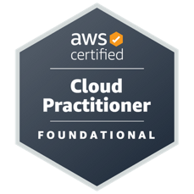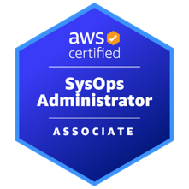**Certificates & Trainings**

* AWS Certified SysOps Administrator – Associate
* AWS Certified Cloud Practitioner

https://www.credly.com/users/kai-poblocki/badges

**Projects/Contracts**

**BMW AG**

**April 2024 – Present**

**Senior AWS DevOps Engineer**

ℹ️ Central Cloud Platform team, focusing on enabling internal customers (e.g. <https://bmw.de>) through robust cloud solutions (AWS).

* AWS CDK (TypeScript):
* CI/CD: GitHub Actions
* Observability: Grafana, Loki, OpenSearch
* Fullstack Development: Vue.js & Nuxt 3

**Rohde & Schwarz SIT**

**October 2023 – March 2024**

**Backend Python Engineer**

ℹ️ Conceptualizing & development of need-to-know domain-based identity and access management in a highly secure Environment.

* Backend development (Python): API & microservice development

**Bundesdruckerei GmbH**

**January 2023 – April 2024**

**Site Reliability Engineer**

ℹ️ Constructing & operating a data science platform in a highly secure environment.

* High Security Kubernetes Bootstrapping: Kubespray
* GitOps: FluxCD
* Monitoring/Logging: Prometheus, Grafana, Loki, Elasticsearch
* Storage: MinIO, Longhorn
* Authentication: Keycloak
* Infrastructure as Code (IaC): Ansible, Helm, Kustomize
* CI/CD with GitLab

**InformMe**

**April 2023 – October 2023**

**Senior AWS DevOps Engineer**

ℹ️ Architecting & Developing GDPR compliant AWS Account Factory for MedTech Startup.

* Architecture: AWS Control Tower Setup, Service Catalog, CfCT Pipeline, Node.js-Lambdas
* Infrastructure as Code: AWS CDK (TypeScript), CloudFormation
* AWS Identity Center (SSO)
* Custom SCPs, Config Rules & SRA
* On-Prem Migration to ECS Fargate & Lambda

**Volkswagen AG (via Rackspace)**

**Dezember 2022 – January 2023**

**Senior Cloud Architect (AWS)**

ℹ️ Supporting Volkswagen short-term around AWS IAM & resolving several findings of an internal revision; analyzing the existing Environment and define security solutions with minimal effort.

**Eurofins**

**July 2021 – November 2022**

**DevOps Engineer (AWS, Kubernetes)**

ℹ️ Architecting & Engineering AWS EKS (Kubernetes) & supporting AWS Services in a Greenfield Project.

* Greenfield: Setting up & Maintaining EKS (Terraform, Crossplane)
* Kubernetes: Helm, ArgoCD, AWS LB Controller, ExternalDNS, External Secrets, Consul, EFS CSI
* Kubernetes monitoring & Logging: Prometheus, Grafana, Loki, Elastic Search
* Kubernetes security: Cluster Hardening (Bottle Rocket)
* Setting up Kubernetes Authentication via OAuth2/OIDC (PingID) & AWS Cognito
* Migrating on-prem workloads to AWS Serverless Stack: Lambda, API Gateway, Cognito, DynamoDB
* Setting up AWS Security: IAM, SSM, CloudTrail, Secret Manager
* Setting up & Maintaining Kubernetes-native development (Skaffold)
* Infrastructure as Code (Terraform, Crossplane)
* CI/CD Pipelines with Azure DevOps & GitLab
* Linux Administration (Debian, Ubuntu, RHEL)
* Programming with Bash, Python & Go
* Data Engineering (AWS RDS: PostgreSQL, MS SQL)

**Siemens AG & Siemens Energy**

**October 2020 – June 2021**

**AWS Cloud/DevOps Engineer**

ℹ️ Migration of on-premise B2B E-Learning Platform to AWS ECS Cluster & general AWS Support for Siemens Energy Carve-Out.

* Infrastructure as Code (Terraform, Ansible)
* Setting up AWS Security: IAM, SSM, CloudTrail, Secret Manager
* Setting up SAML & OIDC Authentication
* Working with Container-Tools: Docker, ECS
* CI/CD Pipelines with GitLab
* Linux administration (Debian, Ubuntu)
* Scripting with Bash, Python, JavaScript & Go
* Data Engineering (AWS RDS: PostgreSQL, MS SQL)
* Configuration and deployments of EC2 autoscaling Groups and Launch Templates with load balancing

**Professional Experience**

**ventx Gmbh**

**June 2020 – December 2022**

**AWS Cloud/DevOps Engineer**

* Working on several DevOps Projects
* Architecting AWS Cloud Frameworks
* CI/CD with BitBucket, Gitlab, Jenkins and Jira
* Linux administration (Debian, Ubuntu, CentOS)
* Working with Container-Tools: Kubernetes, OpenShift, Docker
* Consulting and Support for the DevOps Teams
* Documentation of development
* Building highly available and scalable Multi-Tier AWS infrastructure
* Building serverless infrastructure with AWS Lambda, API Gateway and DynamoDB
* Infrastructure as Code with Terraform and CloudFormation
* Configuration and deployments of EC2 autoscaling Groups and Launch Templates with load balancing

**Bamberger VerlagsGruppe**

**February 2019 – May 2020**

**System Engineer**

* Agile project coordination (e.g. Development of MS Dynamics NAV, Helpdesk-, Wiki-Software)
* Educational data mining/scraping with Python for Learning Analytics and Business Intelligence
* Data engineering (Python: Numpy, Pandas) and maintenance of databases (MySQL, PostgreSQL)
* Web development (HTML, CSS, JavaScript) and deployment (Linux: Debian, Ubuntu, CentOS)
* Defined system standards and processes for provisioning and maintaining software on Linux
* Developed scripts for unattended installations (start scripts, installation automation, etc.)
* Maintaining on-premise server infrastructure (Windows; Linux: Debian, Ubuntu, CentOS; VMWare)
* Project budget planning (e.g. ~105k € image database project, ~95k € ERP development)

**C.C.Buchner Verlag**

**May 2015 – February 2019**

**DevOps Engineer (working student)**

* Creating workflows to optimize processes
* Automating tasks with Python (e.g. conversion scripts for various media outputs)
* Sub-project management and assistance
* Front- and Backend web development (e.g. shop website, ticketing system)
* Maintaining on-premise server infrastructure   
  (WIndows, Linux)

**Computing Centre University of Bamberg**

**January 2013– May 2015**

**System Administrator & IT-Supporter (student assistant)**

* Maintenance of university data centre hard- and software
* Creating install-images for PC-Pools and maintaining hardware
* Network administration (Linux: Debian, Windows Server)

**Education**

**April 2017 – March 2020**

University of Erlangen-Nuremberg:

Analytical Philosophy (*Master of Arts*, grade: 1.2)

**October 2012 – March 2017**

University of Bamberg:

Philosophy and Political Science (*Bachelor of Arts*, grade: 1.5)

**Scholarships**

**March 2016 – March 2020**

Scholarship of the Max Weber Program according to the Bavarian Eliteförderungsgesetz

**November 2017 – March 2020**

Online-Scholarship e-fellows.net

**Languages**

* German: native
* English: fluent (spoken and written)
* Polish: intermediate
* French: basic